Ryan Hemminger, Co-Founder/Founding Board Member,
inspires Thread and helps shape its formative years
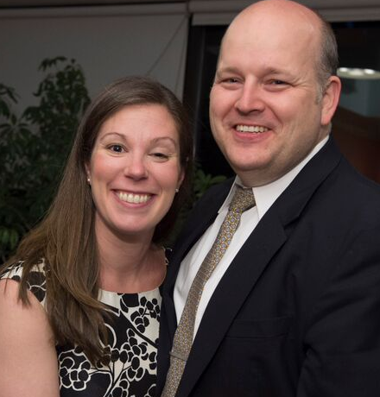
As Ryan and Sarah became friends, started dating, later marrying and dreaming of having a family, they had no idea that their paths would lead them to create and nurture Thread. Ryan’s personal journey not only inspired the ethos of Thread and the development of our innovative model, but the strength and confidence he developed from overcoming early challenges enabled him to establish the Thread Board of Directors and lead it into its early future.

Ryan had been doing well in school until junior high when his family life began to unravel. His mother, a bartender and the family breadwinner, suffered two consecutive car accidents at the hands of drunk drivers. She became addicted to her pain medications and could no longer work. Ryan’s parents began selling her drugs out of their home. Although only 14 years old, Ryan no longer felt he could live under those conditions.

School seemed relatively unimportant compared to his need to survive, so Ryan rarely went to class. He bagged groceries for $4 an hour to make ends meet. Fortunately, when he reached high school, several of his teachers noticed the disconnect between his potential and his academic performance, found out what was going on, and took it upon themselves to help him get through high school. Working as a team, they took turns driving him to school, preparing lunches for him, and helping him with tutoring – basically, whatever it took to help him not only survive but also thrive.

After graduating high school as a varsity athlete with an “A” average, Ryan attended the United States Naval Academy, then worked at the Pentagon; later, at Morgan Stanley. Today he is the Budget Director for the Baltimore City School System.

A program that enriches the community —
and the founders’ lives, too
During Ryan’s senior year of high school, a fourteen year-old freshman named Sarah had her eye on him. Three years later, she followed him to the East Coast to attend college. After getting married, they bought a house in Carroll County and Sarah pursued her Ph.D. in biomedical engineering at the Johns Hopkins University. Yet, despite their accomplishments, Ryan remembers that, with no friends or family nearby, they felt lonely, bored and unfulfilled.

As a first year graduate student, Sarah had passed by Dunbar High School in East Baltimore many times going to class, and thought, “I bet there are kids like Ryan in there who are struggling academically, but could end up at the Naval Academy too.” So when she had the idea to approach the principal about working with ten of their most underperforming freshman and had no clue where to start, she called Ryan, always her first and most reliable thought partner. One long dinner date later — plus the blessing of Dunbar’s principal — Thread was born.

From the beginning, since Thread offered much more than tutoring, Ryan loved hanging out with the students when they came to his house on weekends to play basketball, soccer or football. “It was like having a whole bunch of little brothers,” he said. “My relationships with our kids began to give my life a new dimension of meaning.” At first, the students would make assumptions about his journey. However, as he became more comfortable and shared his story, they began to share their stories, too. Over time, it became healing for both Ryan and our students.

From a group of volunteers to an official non-profit!
For the first six years, Thread was an all-volunteer organization. Not only did Ryan and Sarah both spend time with the students, but they also split the role of Executive Director. Sarah focused on student and volunteer operations while Ryan managed the business operations (finance, fundraising, communications and risk-management). Date nights became strategic planning meetings to discuss both sides of the organization; vacations became stay-cations with 15 teenagers hanging out at their home in Carroll County. Ryan’s personal “hobby” budget became Thread’s general operating budget. As the organization continued to grow, Ryan recognized the need to build infrastructure that could sustain and expand the Thread community. In 2006, he steered Thread through the process of becoming a 501(c)(3) non-profit organization and became the founding Chairman of the Board.

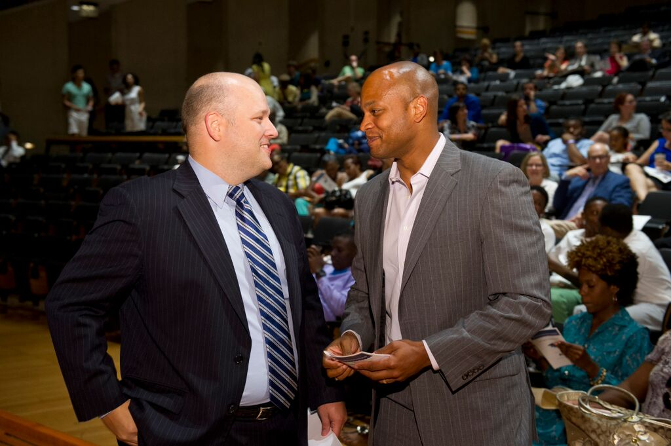
Ryan quickly jumped into action, opened his Rolodex, and recruited a founding Board of Thread volunteers, Johns Hopkins medical students Daniels Bower, Melissa Dattalo, and Romina Ward. Together they worked with Sarah to create Thread’s mission, vision, and values, as well as governing policies. With the Board’s support, Ryan expanded the organization’s business operations. Under his leadership, the Board created the first annual report, built the first website, hosted our first gala, and handled critical functions like insuring the organization. The Board also wrote grants, maintained the financial books, developed the annual budget, and performed critical risk management functions. By leading the business operations, Ryan created critical space for Sarah and other volunteers to focus their time on making sure that students received rides to school, had clean laundry, and adequate food.

Ryan helps steer a maturing organization
When Sarah completed her Ph.D. in early 2010 and decided to forgo her scientific career to work full time as Thread’s Chief Executive Officer, the Board of Directors started its transition from hands-on support to concentrating more fully on governance and strategy. However, Thread only had four staff members, all of whom were focused on student and volunteer operations. Understanding that the small staff didn’t have the capacity to take on the business operations, Ryan worked with Sarah to form an Executive Team of volunteer Officers who specialized in the areas of finance, fundraising, communications, and risk-management, respectively, and would lead teams of specialized volunteers. Ryan recruited the founding Finance Officer, Robert O’Connell and Development Officer, Heather Benz and worked collaboratively with them to build the infrastructure necessary to support the organization’s growth. Ryan’s commitment allowed Thread to thrive with no administrative or fundraising staff until this year, enabling all staff to focus on students and volunteers. This luxury has been a defining part of our students’ success.

As the role of the Board began to evolve, Ryan recognized the need to recruit experienced professionals who shared his love of our students and volunteers. Thread’s Board fully transitioned and Ryan stepped down as Chair in 2012. As Thread heads into its next phase of growth, Ryan continues to play a key role as a Board member working collaboratively with Board Chair Jan Houbolt and Vice-Chair Rodney Foxworth.

In addition to his key work with the Board, Ryan’s impact can be felt in the DNA of so many parts of Thread, such as one of our most significant programs in which every student is required to participate in community service each month. Having seen the power of giving as evidenced by his “family of teachers,” Ryan believed that Thread students would benefit from giving back and understanding that they, too, can have a positive impact on their community. He especially wanted the students to do service that engaged with people, so they could learn from others and see that not only they, but others in the community needed support, as much if not more than they did — and that they were empowered to make a difference in the lives of others. To Ryan, one important measure of Thread’s success is that so many alumni come back to engage with the younger Thread students.

Ryan is convinced that Thread’s achievements to date and its future are based on the fact that at every challenge, we have always asked, “What is best for the kids?” And as he has been since the day Sarah and he founded this unique, successful organization, Ryan Hemminger, our Founding Board Member, will be an integral part of its future.

Tong Zhang, Founding Staff Innovator, joins a Family and
builds organizational infrastructure
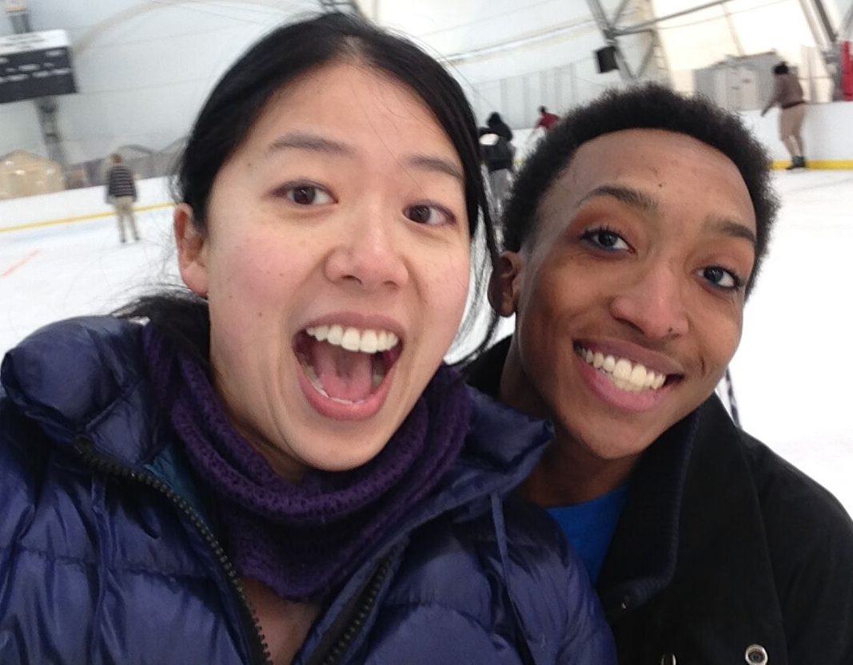
Tong’s journey has taken her a long way. Physically, she has crossed continents, traversed oceans, and crisscrossed the US. Personally, she married her college sweetheart and created an intentional family. Academically, she has become an accomplished scientist, strategist, and executive. Her life’s journey, even at the young age of 31, has taken her further than she could have ever imagined and led to her to becoming a Founding Staff Innovator at Thread.
As Tong explains, “My ancestors fought, not only to be treated more fairly, but to have power over their own lives.” That desire was part of what prompted her family to immigrate to the States from China when she was five years old, and then relocate frequently because of her father’s career as an electrical engineer. Tong spent her early years in Greenbelt, MD, and later, Happy Valley, OR, both racially homogeneous communities at that time, with virtually no Asian population. She saw unfairness in her communities where people from outside of one’s core group were seen as “the other.” While her desire to have power over her own life was a driving force, the racial demographics were overwhelming and left Tong often doing what she could to not stand out.
When Tong came to Baltimore in 2006 to pursue her Ph.D. in immunology at the Johns Hopkins University School of Medicine (JHUSOM), Baltimore became her primary home. In the first two years of graduate school, she had built a strong family of friends among her fellow scientists and for the first time in her life didn’t feel like the “other.” However, in her third year, many of Tong’s friends moved on to other schools and cities. That’s when she knew she had to find a community she could be part of and not allow herself to once again become isolated.
Tong became aware of Thread through the Johns Hopkins Student Outreach Resource Center (SOURCE). When she heard co-founder/(volunteer) CEO Sarah Hemminger speak about renovating a student’s house, Tong was impressed by the organization’s unique pragmatic approach. She was asked to drop off her application at Dunbar, but when she did, Sarah surprised her with, “Would you like to meet your student Eddie?”
Tong saw in Eddie a lot of similarities to her husband, Alex Atienza, when she first met him in college: huge capabilities, very little awareness of his huge capabilities. “I was Alex’s cheerleader, urging him on, encouraging him to go for his dream. I could do that for Eddie, too!” Tong began building a new personal network with Eddie and the others in his Thread Family. Tong also recruited her best friend and fellow graduate student Rose Parkinson, who is still in Eddie’s Thread Family today.
Commitment and creativity
When Eddie’s father lost their home, Sarah and Tong became even closer as Eddie lived with each of them and their respective husbands in turn. Tong remembers, “Sarah, Ryan, Alex and I found ourselves ‘co-parenting’ with Eddie’s father and one another. The disagreements seemed endless. How much time should Eddie spend playing video games versus doing homework? Who was the ‘bad cop?’ But through this storming, we all began to truly understand each other’s values and upbringing. We became an intentional family.”
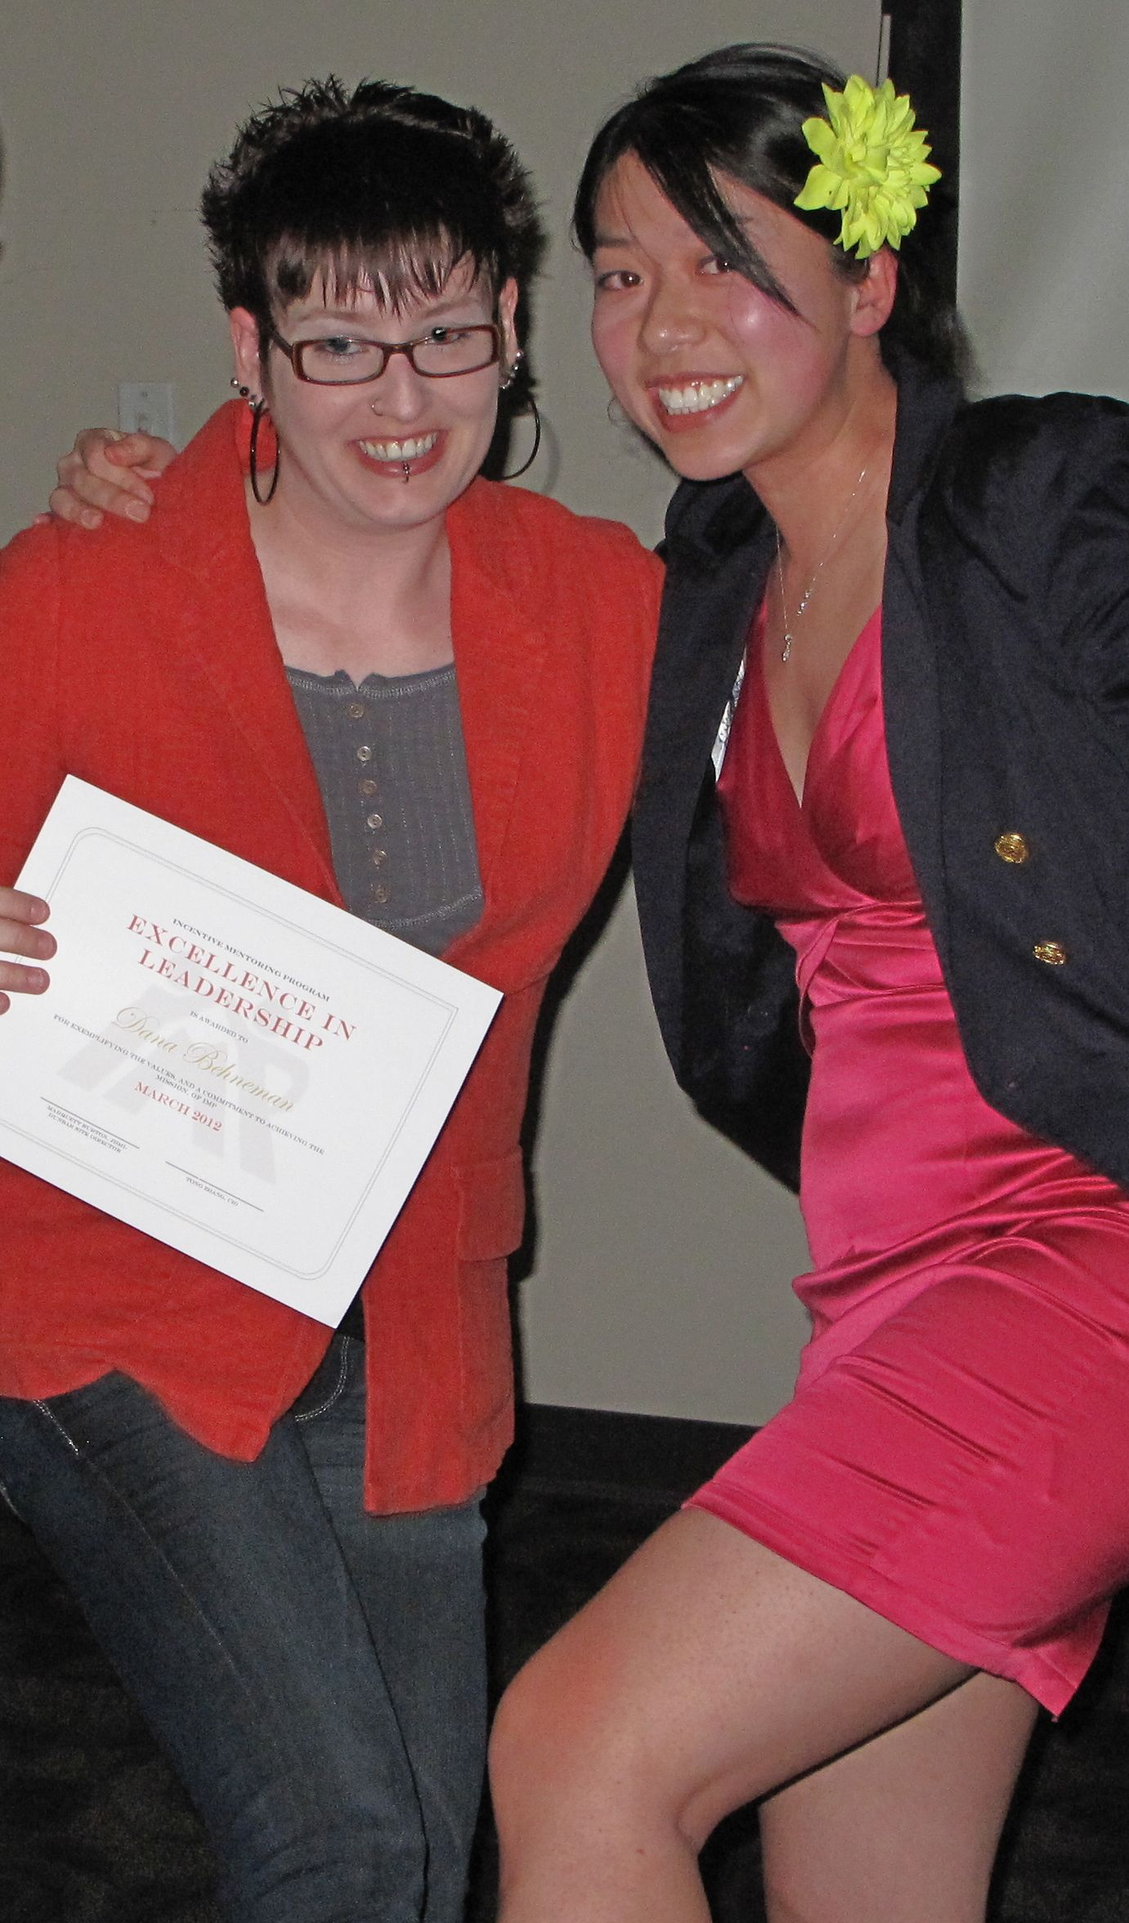
Additionally, Tong was impressed by her fellow volunteers’ commitment, creativity, and focus on making the organization better, and that they were listened to. Later that same year, she made some suggestions about how the website could be used more effectively to facilitate relationships between students and volunteers and was suddenly recruited to become Thread’s volunteer Technology Director. “More for my enthusiasm than my expertise,” Tong insists. As she began spending time envisioning how Thread could not only impact students and volunteers, but also the city of Baltimore, Tong hit her stride. She felt so compelled by the possibilities that after earning her Ph.D. in 2011, she stayed on to join Sarah as a Founding Staff Innovator by becoming Thread’s Chief Innovation Officer (CIO) and Co-President.
In Thread, as CIO, Tong not only had power over her own life, but also the ability to impact the lives of Thread students and volunteers. She had ideas and was encouraged to make them happen. Thread had recently expanded to its second high school site, so Sarah focused on codifying the Thread Family and Tong the Thread Resource Teams, while they simultaneously worked together with Ryan and the Board to refine the vision of the organization. Tong applied her innovative thinking to the development of an internal website, the Thread Mentor Portal, a “one-stop-shop” for Thread Volunteers to record interactions with their student, view Thread calendars of events and access forms. With the newly formed volunteer Technology Team, she and David Wertheimer launched another website, the Thread Wiki, an online encyclopedia of Thread best practices and Baltimore resources that facilitated knowledge sharing across Families, Resource Teams, and between the Dunbar and ACCE sites.
A model for ongoing administration
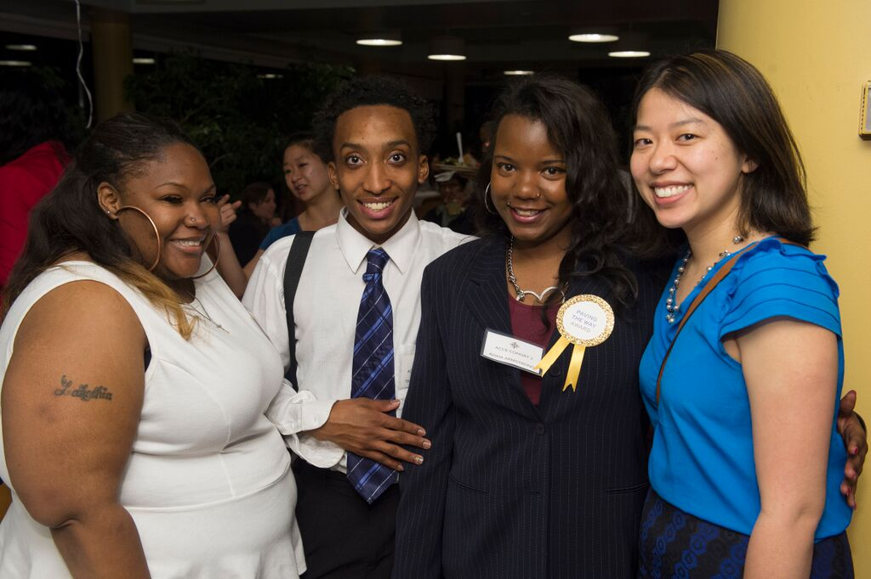
In 2012, as Thread continued to grow and prepare for expansion to a third high school site at Frederick Douglass High School (Douglass), the Board changed its focus to strategy and governance, Sarah took on operations, and Tong transitioned into the role of Chief Operating Officer (COO) to expand her focus to include all of student programming. In this role, Tong built critical infrastructure, systems, and processes to ensure that Thread’s unique culture and exemplary student outcomes continued to flourish as we grew. Still responsible for technology, she was now overseeing all program staff, making sure that they and the volunteers had all the resources and support they needed to best serve our students.

As a Founding Staff Innovator, Tong was not only executing the responsibilities of this new position, she was establishing a foundation of practices and strategies that continue to serve as a model for the ongoing administration of a rapidly growing organization. Sarah comments, "Tong helped us find the difficult balance of building systems and processes as we have grown while prioritizing relationships and ensuring everyone from the students to the volunteers to the staff are taken care of." In 2014, the Tong Zhang Innovation Fellowship was created to honor her tremendous contributions.

The most recent phase of Tong’s journey has once again taken her across the US to be closer to her parents and in-laws.
Thread is forever changed by Tong’s contributions. Her ancestors imparted a drive that helped Tong gain power over her own life and that drive has translated into hundreds of Thread students and volunteers developing the same confidence to impact their own lives and the lives of others.

Robert (Bob) C. Embry, Jr., Founding Champion,
tells our story and challenges our thinking

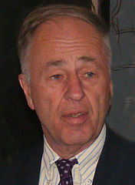
When Robert (Bob) C. Embry Jr. was first introduced to Thread seven years ago, we were a fledgling student group at the Johns Hopkins University serving 31 students with 101 volunteers. While we had successfully graduated our first high school cohort, we were at the beginning stages of navigating the Thread Community Model. It was our first year of Thread Families and Thread Resource Teams; and we had yet to think about replication and scale. As Founding Champion, Bob has played a critical role in Thread’s evolution from a student group to a nationally recognized innovative model for empowering a community of students, volunteers, and collaborators. As a thought partner and donor, he has challenged our thinking at every step, encouraged us to search for truth and opened our eyes to new possibilities.
Before taking the helm as the President of The Abell Foundation, Bob served as President of the Board of School Commissioners for Baltimore City, Assistant Secretary of the U.S. Department of Housing and Urban Development, and Commissioner of the Department of Housing and Community Development for Baltimore City. In 1987, he took leadership of the then-34 year old Foundation committed to acting locally as an agent of change. “We look around the country for unique models and bring them back to Baltimore. We try to find different and effective approaches to meet the challenges,” he explained, adding, “It’s tough for new ideas to get funded.”

“Thread had a great story”
He first heard about Thread (then the Incentive Mentoring Program) in 2008. He immediately recognized that Thread’s mission, to foster students’ academic advancement and personal growth into self motivated, resilient, and responsible citizens, was completely in sync with Abell’s focus on increasing academic achievement for city students. Also, he liked Sarah Hemminger’s analytic approach, stemming from her scientific background. “She has a unique personality and drive and is not afraid of experimentation.”

But most of all, he believed that “Thread had a great story that I thought people should know, so I told them, not necessarily to do something, but they should know about it.” Bob knows a great many people who are committed to making the city, the nation and the world a better place for all people; and he mentioned Thread at every opportunity. In 2009, he suggested that Sarah be invited to speak at a dinner to a group of city leaders who care about Baltimore and regularly get together to learn about innovative programs addressing some of the city’s biggest challenges. The evening was a turning point in Thread’s trajectory.

At the time, Sarah was planning to leave Baltimore and pursue a career in science following completion of graduate school. That evening at the dinner, Bob championed Thread and introduced her to, among others, Shale Stiller, an attorney who was President, CEO and Chairman of the Harry and Jeanette Weinberg Foundation and a Trustee of the Johns Hopkins University (JHU), and Ellen Heller, retired Judge of the Circuit Court for Baltimore City and currently Chair of The Weinberg Foundation. The very next day, Shale asked Sarah for a copy of our annual report, which he and Ellen shared with Ronald J. Daniels, the incoming president of the JHU, a few weeks later. Around the same time, President Daniels was getting to know Baltimore by speaking at gatherings throughout the city. Bob distinctly remembers attending a dinner party in which Daniels was extolling the university, saying that there were a thousand amazing stories he could tell, of Nobel Prize winners, the most prestigious awards and highest achievements in every field. Then he said, “Let me tell you one story, about [Thread]. . .” A few months later, Daniels invited Thread to expand and replicate at the JHU Homewood campus.

Reconceiving the model
Not only Bob’s enthusiasm, but also his keen intellect has helped Thread to thrive. By questioning whether the original organizational structure could support the ever-increasing numbers of volunteers, Bob and Bonnie Legro, Senior Program Officer at The Abell Foundation, prompted the creation of the Threads and the GrandParents’ position. He also encouraged the development of Thread’s signature Volunteer Leadership Development Program, now a key element in recruiting and retaining outstanding volunteers. As a result, Thread has increased six-fold in size and now serves 207 students and alumni with over 750 volunteers.

When Bob was asked to join Thread’s Strategic Planning Committee in 2013, he certainly had plenty on his plate already. But he saw an opportunity to impact Thread’s future with a group of people who, following Sarah’s lead, were open to new ideas. Bob joined Sarah, Tong Zhang (Founding Staff Innovator), Debbie Cameron (Board Chair), Alex Rhee (GP), Tyler Cash-Padgett (HoF), Sophie Dagenais (Director, Baltimore Civic Site, The Annie E. Casey Foundation) and President Daniels. Agreeing to focus on Baltimore, the group wrestled with how to scale up to reach more underserved students in the City. In order to increase the number of high school students and the number of volunteers needed to support them, it was imperative to build, step by step, a strong, well-managed infrastructure that could sustain ambitious growth. Understanding that it wouldn’t happen overnight, they set an aggressive long-term goal of ultimately serving 3,000 students each year (with an annual enrollment of 300 freshmen), reaching approximately 5% of each freshman class across the district.

Bob’s commitment to Thread also extends to providing financial and in-kind support. Since 2009, The Abell Foundation has been a trailblazer as our largest donor for the past six years. Two years ago, recognizing we needed additional office space Bob generously offered space to Thread students, volunteers, and staff at The Abell Foundation. Students love coming to visit the suite that sits high over Harborplace.
“A game-changing model”
As the organization matures and more students cycle through the ten-year program, Bob is very pleased to see Thread alumni (like Maurice Portee and Tynecia Cannie) return to become involved in their communities. He appreciates that these young people provide a unique point of view and leadership that will have a profound effect on Baltimore’s future.
Bob’s hope for Thread’s future is simple and clear: “More volunteers and more students. Right now [with the recent addition of Thread’s third site, The Academies at Frederick Douglass High School], we are adding about 50 new students each year. I look forward to when we can expand to another 500!”
National studies show that students can be lost if they are not given support in the very earliest years of school. Bob Embry sees it differently. “Sarah Hemminger and Thread are proving this wrong. Thread can be a game-changing model for the rest of the country!”

